**Title:** CLAMPS1 Doppler Lidar VAD Data

**Authors:**

Dr. Petra Klein – OU SoM; Executive Associate Dean

[pkklein@ou.edu](mailto:pkklein@ou.edu); ORCiD: 0000-0003-2943-7831

<bliss.science/authors/petra-klien>

Dr. Elizabeth Smith – NOAA/OAR/NSSL; Research Meteorologist

[elizabeth.smith@noaa.gov](mailto:elizabeth.smith@noaa.gov); ORCiD: 0000-0001-6673-1576; [bliss.science/authors/elizabeth-smith](https://bliss.science/authors/elizabeth-smith/)

Dr. Tyler Bell – CIWRO/NSSL; Research Scientist

[tyler.bell@noaa.gov](mailto:tyler.bell@noaa.gov); ORCiD: 0000-0002-0078-2044;   
[bliss.science/authors/tyler-bell/](https://bliss.science/authors/tyler-bell/)

Lydia Bunting – OU-CIWRO/NSSL; Research Associate

[lydia.bunting@noaa.gov](mailto:lydia.bunting@noaa.gov); ORCiD: 0000-0003-3606-7058;

[*bliss.science/authors/lydia-bunting/*](https://bliss.science/authors/lydia-bunting)

**1.0 Dataset Overview**

These files contain 24 hour periods of data collected from the CLAMPS1 Halo Streamline XR Doppler lidar. The Doppler lidar conducts regular conical scans at a set elevation angle. These data are then passed through a typical VAD algorithm to retrieve horizontal wind speed and direction profiles. These data were collected during the PERiLS project.

**1.1 Date range:** 1 March – 30 April 2022

**1.2 Location:** Lake Village, AR; 33.3314 N, 91.2841 W, 33 m elevation

**1.3 Estimated data availability**

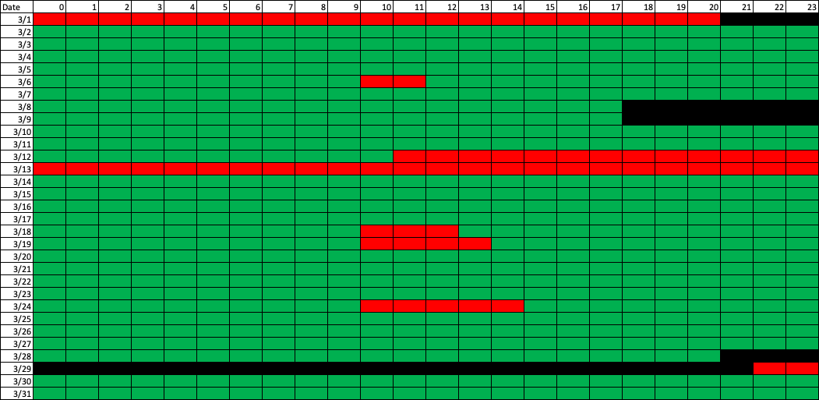

**2.0 Instrument Description**

The Halo Streamline is a commercial platform. The Doppler lidar (DL) is an active remote-sensing instrument that provides range- and time-resolved measurements of radial velocity, attenuated backscatter, and signal-to-noise ratio (SNR). The principle of operation is similar to radar in that pulses of electromagnetic energy (infrared in this case) are transmitted into the atmosphere; the energy scattered back to the transceiver is collected and measured as a time-resolved signal. From the time delay between each outgoing transmitted pulse and the backscattered signal, the distance to the scatterer is inferred. The radial or line-of-sight velocity of the scatterers is determined from the Doppler frequency shift of the backscattered radiation. The DL uses a heterodyne detection technique in which the return signal is mixed with a reference laser beam (i.e., local oscillator) of known frequency. An onboard signal-processing computer then determines the Doppler frequency shift from the power spectra of the heterodyne signal. The energy content of the Doppler spectra can also be used to estimate attenuated backscatter. The DL operates in the near-infrared (IR;1.5 microns) and is sensitive to backscatter from micron-sized aerosols. Aerosols are ubiquitous in the lower troposphere and behave as ideal tracers of atmospheric winds. In contrast to radar, the DL is capable of measuring radial velocities under clear-sky conditions with very good precision – typically ~10 cm/sec (Newsom and Krishnamurthy 2020). It is important to note that DL scans are fully user configurable, so special attention should be paid to the scan strategy applied for this dataset.

Instrument specifications:

|  |  |
| --- | --- |
| Max range | 8 km (aerosol load dependent) |
| Min. range | 50-90m |
| Nyquist Limit | ~39 m/s |
| Range gate | Configurable, 18-60m |
| Precision | Velocity: <0.2 m/s |

**3.0 Data collection and processing:**

For the TRACER-AQ campaign, the CLAMPS1 Doppler lidar collected PPI scans at 70 deg elevation every 20 minutes. The Doppler lidar provides range-resolved, line-of-sight measurements of radial velocity, intensity (signal-to-noise ratio [SNR]+1), and attenuated backscatter. In the case of PPI scans meant for VAD analysis, these data are passed through a VAD code to produce profiles of horizontal wind speed and direction. Vertical velocity is also provided, but it is not as high quality as vertical velocity more directly measured by vertical stares. The provided files provide the intensity field (SNR+1), which can be used as a ‘filter’ for noise. A good rule of thumb cutoff is 1.01.

**4.0 Data format:**

Data are provided in netcdf format. The typical naming convention is clampsdlvad1turnC1.c1.YYYYMMDD.HHmmss.cdf, following closely to ARM file naming convention. The files have time and height dimensions.

Variables provided:

|  |  |  |
| --- | --- | --- |
| Name | Dimension | Unit |
| base_time | Single value | Seconds (since 00 UTC 1 Jan 1970) |
| time_offset | Time | Second (since base_time) |
| hour | Time | Hours since 00UTC this day |
| height | Height | km AGL |
| wspd | Time, Height | m/s, wind speed |
| wdir | Time, Height | Deg, wind direction |
| rms | Time, Height | m/s, RMS between observed velocity & VAD fitted value |
| intensity | Time, Height | Unitless, SNR+1 |
| lat | Time | Deg N, latitude |
| lon | Single value | Deg W, longitude |
| alt | Single value | m MSL, altitude above mean sea level |

**5.0 Data Remarks**

Note that a heading value should have been applied to the Doppler lidar to rotate the winds appropriately. Always verify this has been done, since it is not always applied by default.

Data should be consistently available, but note that periods of precipitation, fog, or other very low cloud may limit the level to which good data are collected.

**6.0 References**

*Newsom, R. K., R. Krishnamurthy, 2020: Doppler lidar (DL) handbook. DOE Office of Science Atmospheric Radiation Measurement (ARM) Program (United States). DOE/SC/ARM/TR-101.*

**7.0 Appendix**

GCMD Science Keywords: WIND PROFILES; WIND VELOCITY/SPEED PROFILES; WIND DIRECTION PROFILES; VERTICAL WIND VELOCITY/SPEED