Title: CLAMPS2 Doppler Lidar Vertical Stare Data
Authors:
Dr. Elizabeth Smith – NOAA/OAR/NSSL; Research Meteorologist
elizabeth.smith@noaa.gov; ORCiD: 0000-0001-6673-1576; bliss.science/authors/elizabeth-smith

Dr. Tyler Bell – CIWRO/NSSL; Research Scientist
tyler.bell@noaa.gov; ORCiD: 0000-0002-0078-2044;
bliss.science/authors/tyler-bell/

Lydia Bunting – OU-CIWRO/NSSL; Research Associate
lydia.bunting@noaa.gov; ORCiD: 0000-0003-3606-7058;
bliss.science/authors/lydia-bunting/

Data content questions can be directed to any author OR to the contacts listed at apps.nssl.noaa.gov/CLAMPS

1.0 Dataset Overview
These files contain 24 hour periods of data collected from the CLAMPS2 Halo Streamline XR+ Doppler lidar. While not conducting other scans, the lidar directs the beam to zenith, allowing for the measurement of vertical velocity. These data were collected during the CHEESEHEAD project.

  - Date range: 6 October 2021 – 18 January 2022.
1.2 Location: Crested Butte, CO, 38.86971° N, 106.98782° W, 2715 m elevation
1.3 Estimated data availability
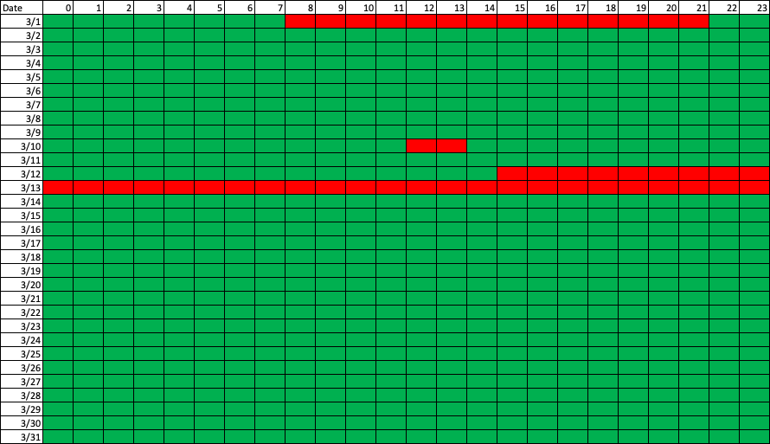
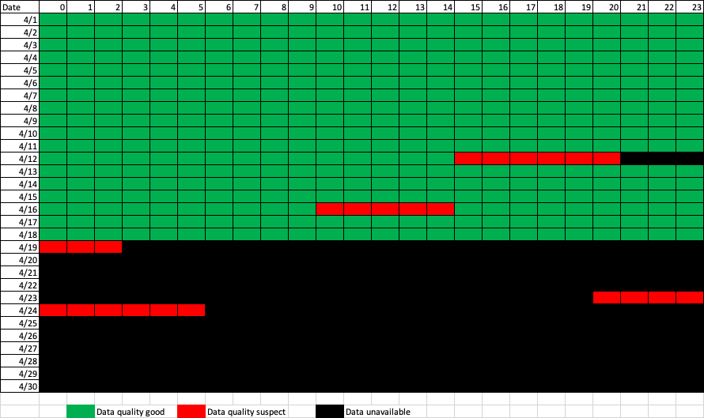

2.0 Instrument Description
The Halo Streamline XR+ is a commercial platform. The Doppler lidar (DL) is an active remote-sensing instrument that provides range- and time-resolved measurements of radial velocity, attenuated backscatter, and signal-to-noise ratio (SNR). The principle of operation is similar to radar in that pulses of electromagnetic energy (infrared in this case) are transmitted into the atmosphere; the energy scattered back to the transceiver is collected and measured as a time-resolved signal. From the time delay between each outgoing transmitted pulse and the backscattered signal, the distance to the scatterer is inferred. The radial or line-of-sight velocity of the scatterers is determined from the Doppler frequency shift of the backscattered radiation. The DL uses a heterodyne detection technique in which the return signal is mixed with a reference laser beam (i.e., local oscillator) of known frequency. An onboard signal-processing computer then determines the Doppler frequency shift from the power spectra of the heterodyne signal. The energy content of the Doppler spectra can also be used to estimate attenuated backscatter. The DL operates in the near-infrared (IR;1.5 microns) and is sensitive to backscatter from micron-sized aerosols. Aerosols are ubiquitous in the lower troposphere and behave as ideal tracers of atmospheric winds. In contrast to radar, the DL is capable of measuring radial velocities under clear-sky conditions with very good precision – typically ~10 cm/sec (Newsom and Krishnamurthy 2020). It is important to note that DL scans are fully user configurable, so special attention should be paid to the scan strategy applied for this dataset.

Instrument specifications:
Max range | 12 km (aerosol load dependent)
Min. range | 50-90m
Nyquist Limit | ~39 m/s
Range gate | Configurable, 18-60m
Precision | Velocity: <0.2 m/s

3.0 Data collection and processing:
For the PERiLS campaign, the CLAMPS2 Doppler lidar collected PPI scans at 60 deg elevation every 5 minutes. The Doppler lidar provides range-resolved, line-of-sight measurements of radial velocity, intensity (signal-to-noise ratio [SNR]+1), and attenuated backscatter. In the case of PPI scans meant for VAD analysis, these data are passed through a VAD code to produce profiles of horizontal wind speed and direction. Vertical velocity is also provided, but it is not as high quality as vertical velocity more directly measured by vertical stares. The provided files provide the intensity field (SNR+1), which can be used as a ‘filter’ for noise. A good rule of thumb cutoff is 1.01.

4.0 Data format:
Data are provided in netcdf format. The typical naming convention is clampsdlfpC2.c1.YYYYMMDD.HHmmss.cdf, following closely to ARM file naming convention. The files have time and height dimensions.

Variables provided:
Name | Dimension | Unit
base_time | Single value | Seconds (since 00 UTC 1 Jan 1970)
time_offset | Time | Second (since base_time)
hour | Time | Hours since 00UTC this day
height | Height | km AGL
azimuth | Time | Deg, azimuth angle of the scanner
elevation | Time | Deg, elevation angle of the scanner
velocity | Time, Height | m/s, NOTE that this is the w field, so positive is up, negative is down despite the netcdf comment
intensity | Time, Height | Unitless, SNR+1
backscatter | Time, Height | km⁻¹ sr⁻¹, attenuated backscatter
cbh | Time | km AGL, cloud base height
internal_temp, internal_rh, tec_flag, and tec_voltage are all ‘housekeeping’ variables noting the instrument temperature and rh and the thermoelectric cooler status
lat | Time | Deg N, latitude
lon | Single value | Deg W, longitude
alt | Single value | m MSL, altitude above mean sea level

5.0 Data Remarks
Data should be consistently available, but note that periods of precipitation, fog, or other very low cloud may limit the level to which good data are collected. Note also that vertical velocity in light precipitation will be contaminated by the fall speed of the precipitation itself.

6.0 References
Newsom, R. K., R. Krishnamurthy, 2020: Doppler lidar (DL) handbook. DOE Office of Science Atmospheric Radiation Measurement (ARM) Program (United States). DOE/SC/ARM/TR-101.

