**Title:** NSSL Mobile Lidar Truck PERiLS 2022

**Authors:**   
Dr. Elizabeth Smith – NOAA/OAR/NSSL; Research Meteorologist

[*elizabeth.smith@noaa.gov*](mailto:elizabeth.smith@noaa.gov)*; ORCiD:0000-0001-6673-1576;* [*bliss.science/authors/elizabeth-smith*](https://bliss.science/authors/elizabeth-smith/)

*and*

Dr. Tyler Bell – CIWRO/NSSL; Research Scientist

[*tyler.bell@noaa.gov*](mailto:tyler.bell@noaa.gov)*; ORCiD: 0000-0002-0078-2044;*[*bliss.science/authors/tyler-bell/*](https://bliss.science/authors/tyler-bell/)

**1.0 Dataset Overview**

These files contain periods of data collected from the NSSL Lidar Truck Halo Streamline XR+ Doppler lidar. These data were collected during the PERiLS 2022 project. The Doppler lidar conducts regular conical scans at a set elevation angle as well as vertically pointing stares. These data are then passed through a typical VAD algorithm to retrieve horizontal wind speed and direction profiles. This platform was nomadic, and collected data on a deployment-to-deployment basis, so availability depends on the deployment decisions made each day by the project.

These data are not final. See remark in Section 5.2

**1.1 Date range:** 22 March -- 13 April 2022

**1.2 Region of data collection:** Southeastern US (TN, AR, MS, AL)

**1.3 Estimated data availability**

IOP1: 2022-03-22 13:15 UTC – 2022-03-22 21:23 UTC

IOP2: 2022-03-30 14:00 UTC – 2022-03-30 23:15 UTC

IOP3: 2022-04-05 9:00 UTC – 2022-04-05 17:15 UTC

IOP4: 2022-04-13 15:15 UTC – 2022-04-13 21:45 UTC

**2.0 Instrument Description**

The Halo Streamline XR+ is a commercial platform. The Doppler lidar (DL) is an active remote-sensing instrument that provides range- and time-resolved measurements of radial velocity, attenuated backscatter, and signal-to-noise ratio (SNR). The principle of operation is similar to radar in that pulses of electromagnetic energy (infrared in this case) are transmitted into the atmosphere; the energy scattered back to the transceiver is collected and measured as a time-resolved signal. From the time delay between each outgoing transmitted pulse and the backscattered signal, the distance to the scatterer is inferred. The radial or line-of-sight velocity of the scatterers is determined from the Doppler frequency shift of the backscattered radiation. The DL uses a heterodyne detection technique in which the return signal is mixed with a reference laser beam (i.e., local oscillator) of known frequency. An onboard signal-processing computer then determines the Doppler frequency shift from the power spectra of the heterodyne signal. The energy content of the Doppler spectra can also be used to estimate attenuated backscatter. The DL operates in the near-infrared (IR;1.5 microns) and is sensitive to backscatter from micron-sized aerosols. Aerosols are ubiquitous in the lower troposphere and behave as ideal tracers of atmospheric winds. In contrast to radar, the DL is capable of measuring radial velocities under clear-sky conditions with very good precision – typically ~10 cm/sec (Newsom and Krishnamurthy 2020). It is important to note that DL scans are fully user configurable, so special attention should be paid to the scan strategy applied for this dataset.

Instrument specifications:

|  |  |
| --- | --- |
| Max range | 12 km (aerosol load dependent) |
| Min. range | 50-90m |
| Nyquist Limit | ~39 m/s |
| Range gate | Configurable, 18-60m |
| Precision | Velocity: <0.2 m/s |

**2.1 Platform Configuration**

For this project, one Doppler lidar was mounted onto the NSSL mobile lidar truck. This meant that one lidar shares the duty of scanning to profile horizontal winds and pointing vertically to observe vertical velocity. This data set includes only the vertical velocity information.

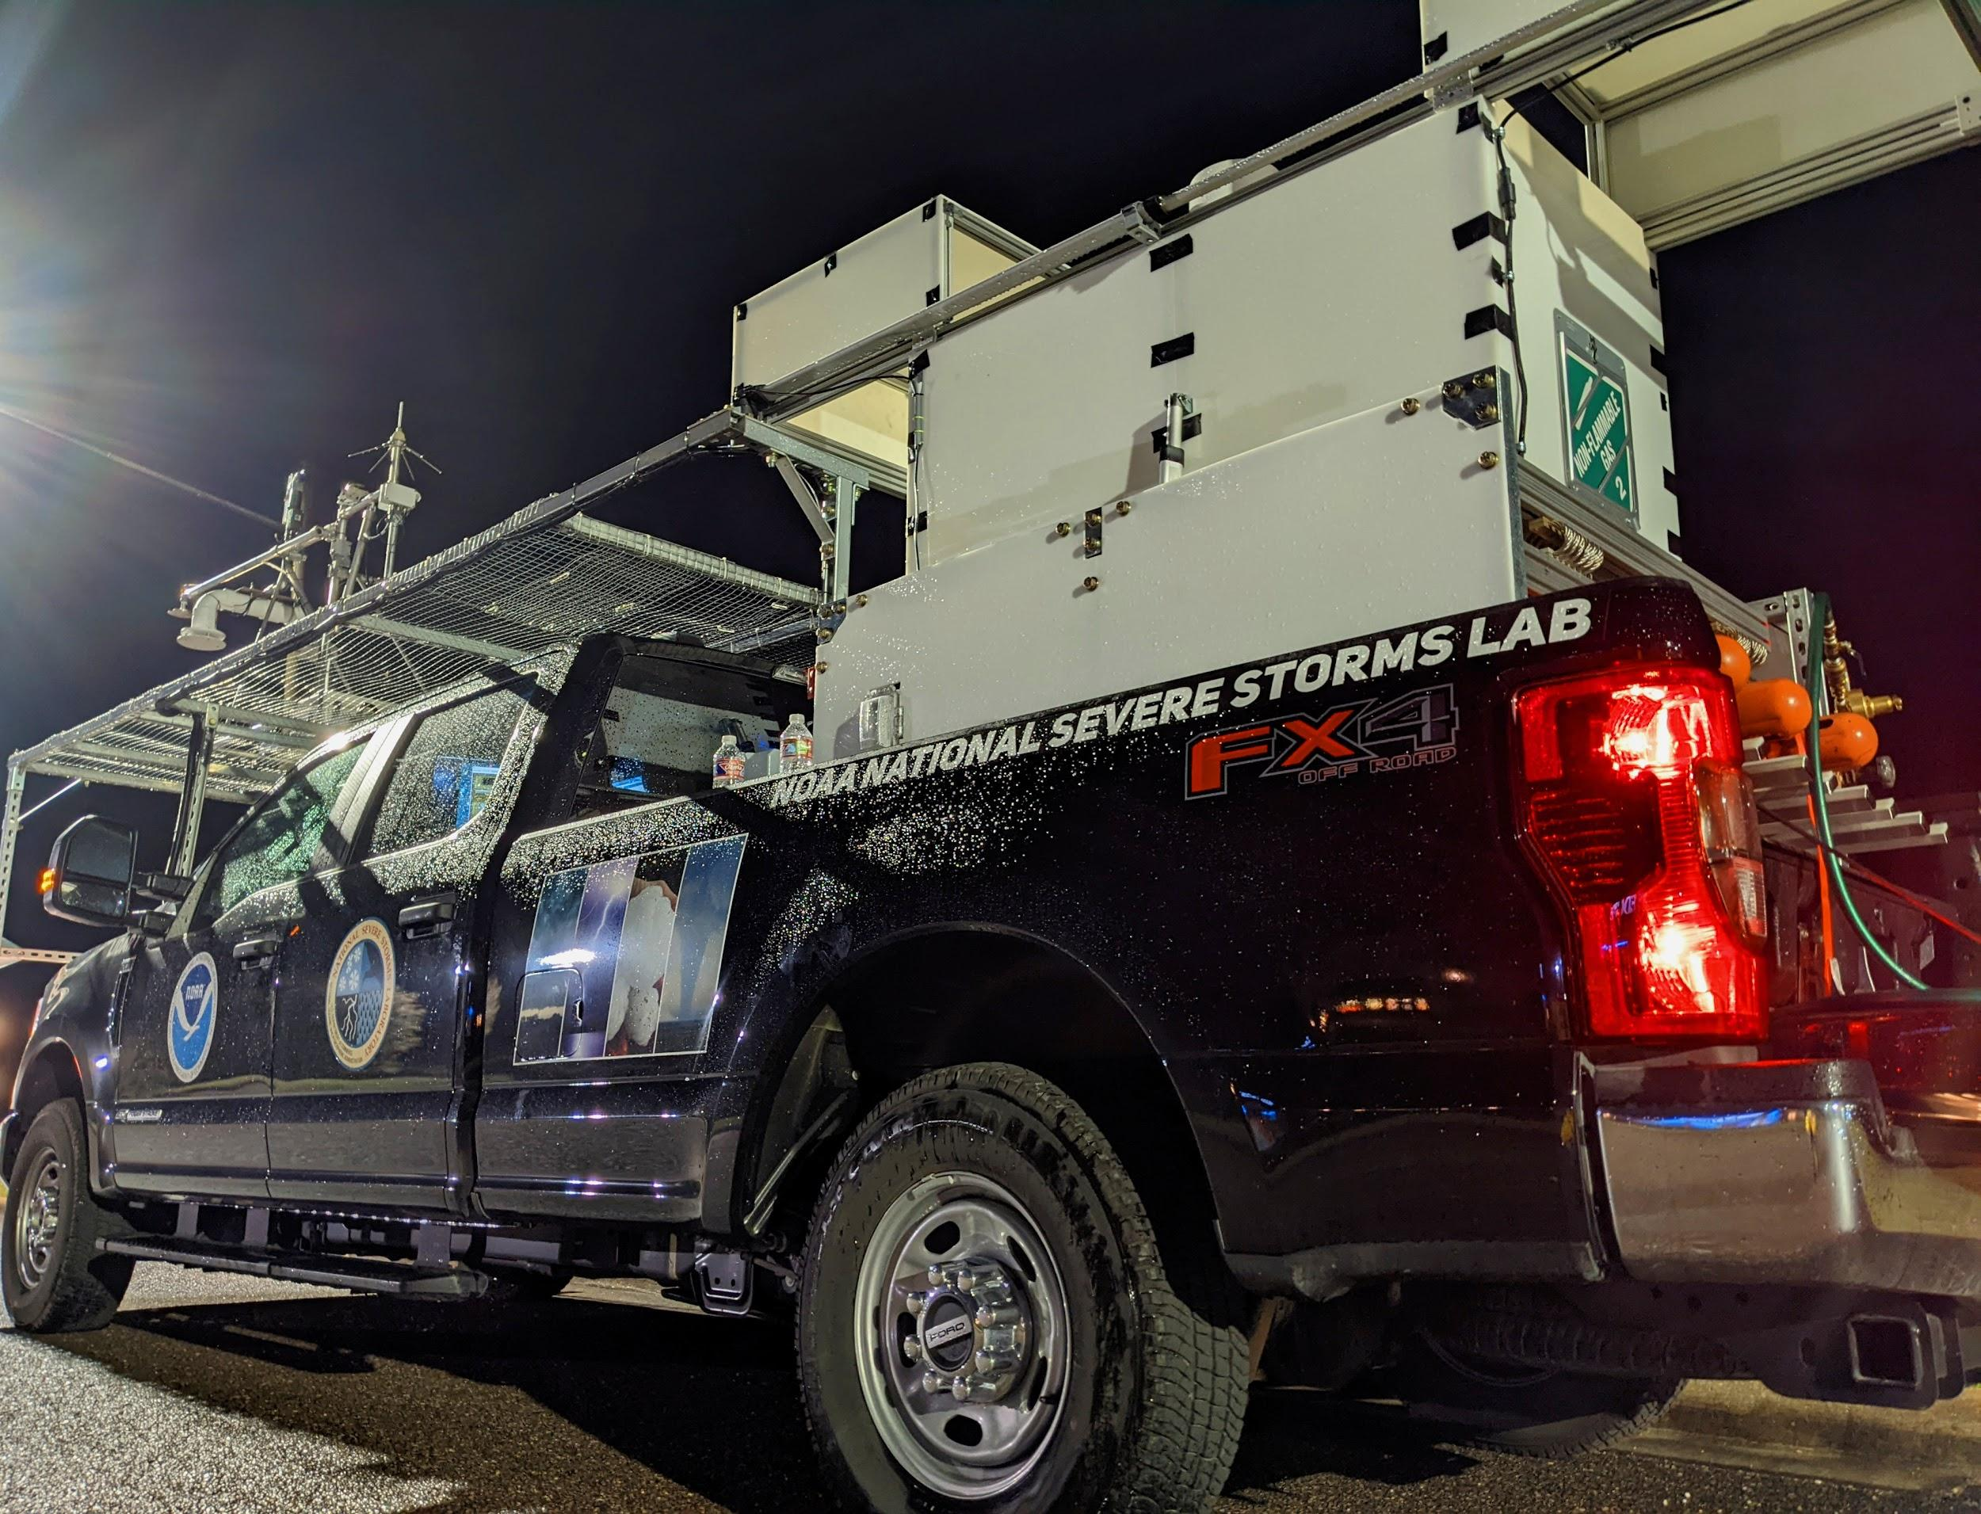

*Figure 1. This photo shows the NSSL Doppler lidar truck as it appeared during PERiLS 2022 in deployment mode. The Doppler lidar’s scanner head is visible protruding from the center of the open enclosure system in the back of the pickup truck. The truck also launched radiosondes and carried a mobile mesonet rack, which are separate datasets.*

**3.0 Data collection and processing:**

For the PERiLS campaign, the Doppler lidar collected PPI scans at 70 deg elevation every 5 minutes. The Doppler lidar provides range-resolved, line-of-sight measurements of radial velocity, intensity (signal-to-noise ratio [SNR]+1), and attenuated backscatter. In the case of PPI scans meant for VAD analysis, these data are passed through a VAD code to produce profiles of horizontal wind speed and direction. Vertical velocity is also provided, but it is not as high quality as vertical velocity more directly measured by vertical stares. The provided files provide the intensity field (SNR+1), which can be used as a ‘filter’ for noise. A good rule of thumb cutoff is 1.01.

**3.1 Vertical Velocities**

The Doppler lidar provides range-resolved, line-of-sight measurements of radial velocity, intensity (signal-to-noise ratio [SNR]+1), and attenuated backscatter. This measurement of vertical velocity is much more direct than that provided within the CSM wind files, described below. The provided files provide the intensity field (SNR+1), which can be used as a ‘filter’ for noise. A good rule of thumb cutoff is 1.01.

**3.2 Horizontal Winds**

The horizontal winds were produced using the Step-Stare mode feature available on Halo Streamline DLs. In this mode, the scanner head stops at each point in a scan to capture its sample. These scans were post-processed using the VAD method to get the horizontal wind speed and direction.

**4.0 Data format:**

Data are provided in netcdf format. The typical naming convention is dltruckdlfpDL1.c1.YYYYMMDD.HHmmss.cdf and dltruckdlvadDL1.c1.YYYYMMDD.HHmmss.cdf, following closely to ARM file naming convention. The files have time and height dimensions.

Variables provided:

*Vertical Velocity (dlfp)*

|  |  |  |
| --- | --- | --- |
| Name | Dimension | Unit |
| base_time | Single value | Seconds (since 00 UTC 1 Jan 1970) |
| time_offset | Time | Second (since base_time) |
| hour | Time | Hours since 00UTC this day |
| height | Height | km AGL |
| azimuth | Time | Deg, azimuth angle of the scanner |
| elevation | Time | Deg, elevation angle of the scanner |
| velocity | Time, Height | m/s, **NOTE that this is the *w* field, so positive is up, negative is down despite the netcdf comment** |
| intensity | Time, Height | Unitless, SNR+1 |
| backscatter | Time, Height | km-1 sr-1, attenuated backscatter |
| cbh | Time | km AGL, cloud base height |
| internal_temp, internal_rh, tec_flag, and tec_voltage are all ‘housekeeping’ variables noting the instrument temperature and rh and the thermoelectric cooler status | | |
| lat | Time | Deg N, latitude |
| lon | Single value | Deg W, longitude |
| alt | Single value | m MSL, altitude above mean sea level |
|  |  |  |

*Horizontal winds (dlvad)*

|  |  |  |
| --- | --- | --- |
| Name | Dimension | Unit |
| base_time | Single value | Seconds (since 00 UTC 1 Jan 1970) |
| time_offset | Time | Second (since base_time) |
| hour | Time | Hours since 00UTC this day |
| height | Height | km AGL |
| wspd | Time, Height | m/s, wind speed |
| wdir | Time, Height | Deg, wind direction |
| rms | Time, Height | m/s, RMS between observed velocity & VAD fitted value |
| intensity | Time, Height | Unitless, SNR+1 |
| lat | Time | Deg N, latitude |
| lon | Single value | Deg W, longitude |
| alt | Single value | m MSL, altitude above mean sea level |

**5.0 Data Remarks**

**5.1.** Data should be consistently available, but note that periods of precipitation, fog, or other very low cloud may limit the level to which good data are collected. Note also that vertical velocity in light precipitation will be contaminated by the fall speed of the precipitation itself.

**5.2.** A quick comparison with the radiosondes launched from the NSSL Lidar Truck shows that there is a persistent wind direction offset to the horizontal winds in the current dataset (5-10 degrees). This is likely due to how the post processing of the winds takes place. To ease operator burden during deployments, the FluxGate on the Mobile Mesonet rack fixed to the truck is used to correct the wind direction of the lidar instead of having to manually input the lidar heading into the lidar software. We hypothesize that the heading from the FluxGate is offset slightly from the true direction. This is something that is currently being investigated and we will provide a corrected dataset in the future.

**6.0 References**

*Newsom, R. K., R. Krishnamurthy, 2020: Doppler lidar (DL) handbook. DOE Office of Science Atmospheric Radiation Measurement (ARM) Program (United States). DOE/SC/ARM/TR-101.*

**7.0 Appendix**

GCMD Science Keywords: WIND PROFILES; WIND VELOCITY/SPEED PROFILES; WIND DIRECTION PROFILES; VERTICAL WIND VELOCITY/SPEED